Special Programs
Hold A Mass specifically for those with Autism -
- Dim lighting
- Allow for individuals to move around Church
- Make it known that movement and noises will be part of the mass and will be accepted as a form of prayer
- Calming music

Hold A Mass specifically for the Hearing Impaired -
- Offer listening devices
- Possibly have an interpreter

Hold A Mass specifically for the Hearing Impaired
- Offer prayers, responses and music in Braille form
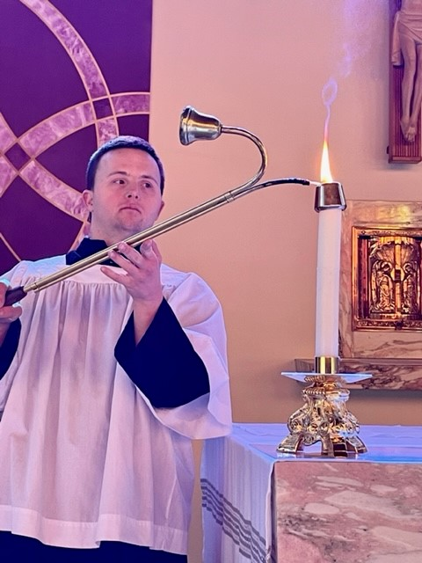

Create A Mentorship Program for greeters, servers, and offertory
- Form a mentorship program to guide and train someone with a disability to be a greeter, server or offertory
- Depending on the disability mentors can assist, model and find ways to adapt tasks
- A good reference is How To Welcome Include, and Catechize Children with Autism and Other Special Needs, by Lawrence R. Sutton, PH. D.

www.thegoldenruleproject.org

